**DAILY ONLINE ACTIVITIES SUMMARY**

|  |  |  |  |  |  |  |  |
| --- | --- | --- | --- | --- | --- | --- | --- |
| **Date:** | **12/06/2020** | | | | **Name:** | **Churashma** | |
| **Sem & Sec** | **4th SEM 'A' Section** | | | | **USN:** | **4AL18CS019** | |
| **Online Test Summary** | | | | | | | |
| **Subject** | | **Aadalitha kannada** | | | | | |
| **Max. Marks** | | **25** | | **Score** | | **13** | |
| **Certification Course Summary** | | | | | | | |
| **Course** | **Introduction to neural networks and deep learning** | | | | | | |
| **Certificate Provider** | | | **greatlearning academy** | **Duration** | | | **9.5 hours** |
| **Coding Challenges** | | | | | | | |
| **Problem statement 1: Given two positive integer start and end. The task is to write a Python program to print all Prime numbers in an Interval.** | | | | | | | |
| **Status: completed** | | | | | | | |
| **Uploaded the report in Github** | | | | **yes** | | | |
| **If yes Repository name** | | | | **https://github.com/Churashma/Lockdown-coding** | | | |
| **Uploaded the report in slack** | | | | **yes** | | | |

ONLINE TEST DETAILS: Aadalitha kannada test was scheduled from 11:30 am to 11:55am .The portion for the IA was all 10 chapters there were 25 questions and the time assigned was 25 minutes the questions were mcq type.

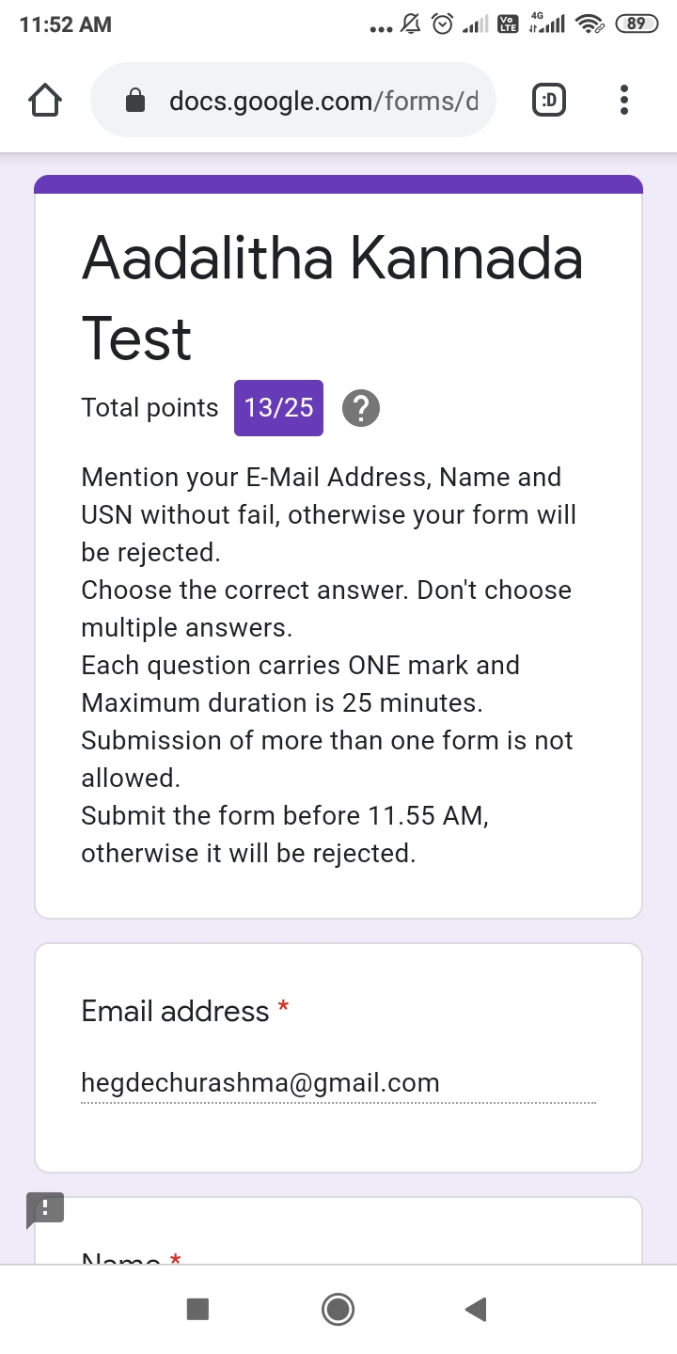

CERTIFICATION COURSE DETAILS: Today I studied about feed forward neural networks and back propagation and gradient descent. A feedforward neural network is an artificial neural network wherein connections between the nodes do not form a cycle. As such, it is different from its descendant: recurrent neural networks.This is done using gradient descent, which by definition comprises two steps: calculating gradients of the loss/error function, then updating existing parameters in response to the gradients, which is how the descent is done.

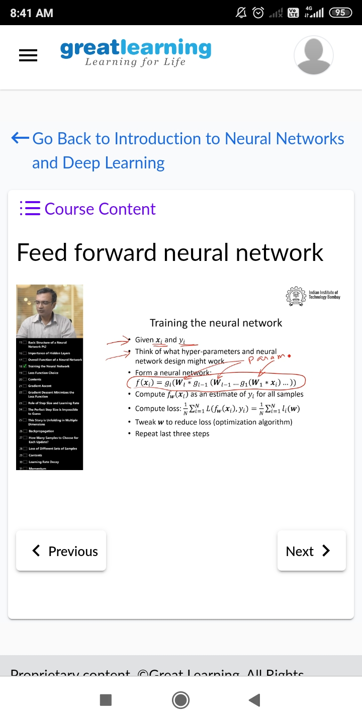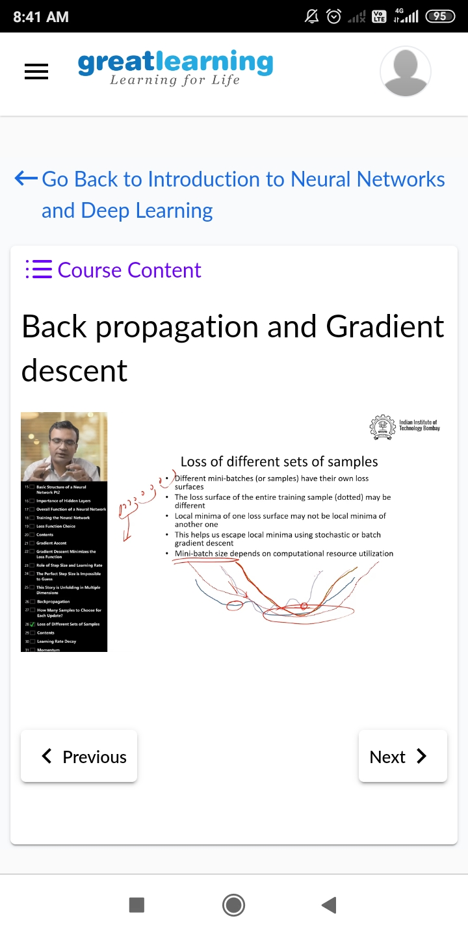

**CODING CHALLENGES DETAILS**:

**Problem statement 1: Given two positive integer start and end. The task is to write a Python program to print all Prime numbers in an Interval.**

